Setup Test Directory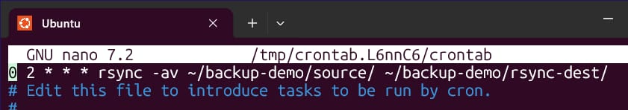
Full Backup using tar -
-c create
-v verbose
-z gzip
-f filename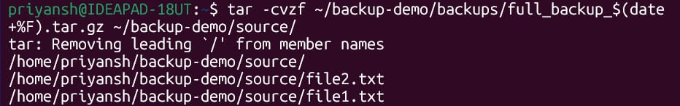
Verify the backup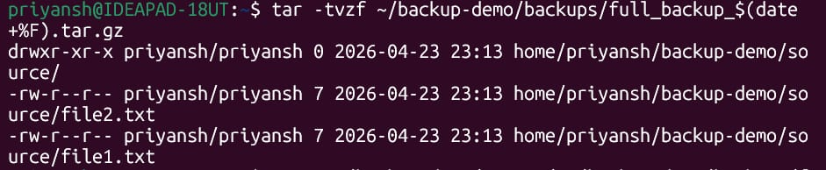
Stimulate an incremental change and then incremental backup (only newer files) 